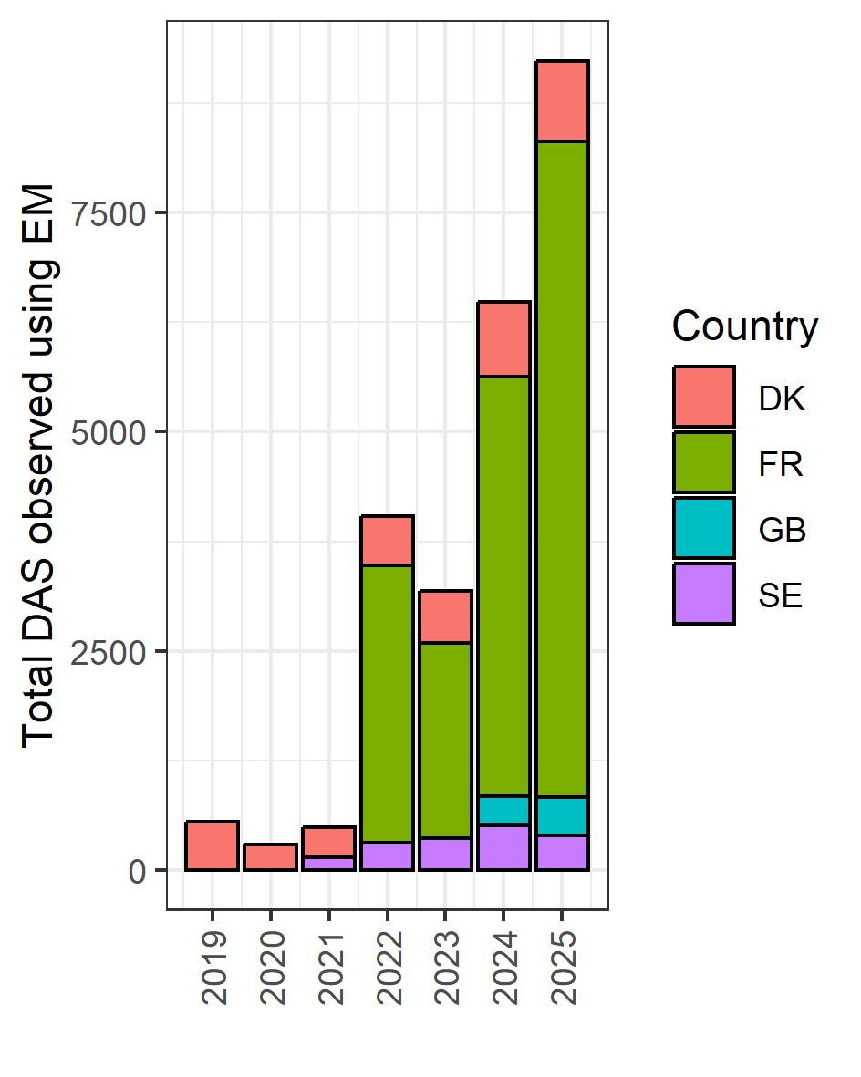
Total monitored (observed) number of days at sea reported by each country with electronic monitoring.

